Catholic Teaching Opposes Mass Deportation

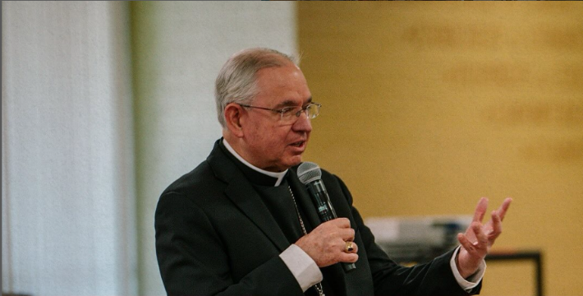
The new presidential administration has committed to “mass deportation,” that is, their plan to deport all of the persons without legal status currently in the United States (est. 11 million). The administration further plans to deport all those with certain forms of temporary legal status, including Temporary Protected Status or TPS (offered during disasters and emergencies), “parole” (a transitional status for humanitarian reasons), and those awaiting adjudication of asylum claims (est. 3-4 million).
Photo credit: Archdiocese of Los Angeles

Catholic leaders have come forth to express their objections. Archbishop Gomez has written, “Deportation is not an immigration policy.” Cardinal Robert McElroy, formerly Bishop of San Diego and now the Archbishop of Washington, DC, summarized: “Having a wider indiscriminate massive deportation across the country would be something that would be incompatible with Catholic doctrine.” Here are some reasons why Catholic leaders have found mass deportation to be contrary to Catholic teaching:

- First, there is the biblical witness against it. Dozens of passages in the Old Testament or Hebrew Bible specifically mention the Israelites’ responsibilities toward the “resident alien” or immigrant (Hebrew gerim) as part of their covenant with God (e.g., Exodus 22:21-22 or 23:9, Leviticus 19:33-34 or 24:22, Deuteronomy 10:18-19, Ezekiel 47:22-23). God’s people are reminded that they were once foreigners mistreated in the land of Egypt, an invocation relevant to Americans, whose ancestors were often mistreated upon arrival here. Immigrants are not to be cheated at work (Deut. 24:14), must be provided for when they are poor (Leviticus 19:10 and 23:22), and there should not be a different more severe law for resident aliens compared to Israelites (Exodus 12:49, Numbers 9:14 or 15:15-16). In the New Testament, the Son of Man judges the living and the dead based on whether they have welcomed the stranger (Matthew 25:31-46). It is hard to reconcile this ethos of welcome with the mass deportation of 14 million people.
When an alien resides with you in your land, you shall not oppress the alien. The alien who resides with you shall be to you as the native-born among you; you shall love the alien as yourself, for you were aliens in the land of Egypt: I am the Lord your God (Leviticus 19:33-34).
- One of the chief sources for Catholic teaching on immigration is Catholic Social Teaching, where we are told that people have a right to migrate if they cannot flourish in their homeland, including “in cases of non-legal migration” (Ecclesia in America 65). The Compendium of the Social Doctrine of the Church specifically forbids mass deportation and condemns it alongside genocide and human trafficking. Pope St. John Paul II lists indiscriminate deportation as an “intrinsic evil” in Veritatis Splendor (80), that is, something that cannot be justified under any circumstances.

- Because in Catholic teaching immigrants are first and foremost persons with dignity, made in God’s image, they may not be mistreated, reduced to a vague category, or stereotyped as criminals. Pope St. John XXIII argues in Pacem in Terris (25) that because immigrants belong to the human family, they cannot be dismissed or disregarded simply because they are from another country. Because of this, Catholic leaders have been particularly critical of deportation efforts that pay no attention to the person’s story as a human being—whether they have built a life in the United States, how long they have resided here, or whether they have family or children who are US citizens. The bishops of the United States and Mexico insist that unauthorized immigrants have the right to expect respect (Strangers No Longer, 38-39).
- Because Catholic teaching sees human beings as essentially relational—not isolated individuals but persons in webs of relationship—Catholic critiques of mass deportation often focus on the breakup of families. Many people do not realize that US law affords immigrant parents, even single parents, no right to stay in order to care for their US citizen children. The Church has strongly opposed the separation of parents from their children, and in mass deportation there would no way to avoid doing this on a grander scale than we have ever seen before.
- This opposition to mass deportation is not necessarily an opposition to deportation in all circumstances. Because we are relational people, we are also people who belong to nations that require order, and Catholic social teaching asserts that nations have a right to police their borders. As a universal Church, we also understand that a person can have a good life and a good life of faith living in another country. Church leaders warn, however, against enforcement exacted out of an exaggerated fear of crime, or a desire not to share wealth. We cannot prioritize the good of our own nation in such a way that inflicts deep harm on the people born in another nation. That is not “prioritizing our own” so much as selfishness writ large.
“The Church recognizes the right of sovereign nations to control their territories but rejects such control when it is exerted merely for the purpose of acquiring additional wealth. More powerful economic nations, which have the ability to protect and feed their residents, have a stronger obligation to accommodate migration flows. (US and Mexican Bishops, Strangers No Longer: Together on the Journey of Hope, 36).
- Finally, the Church is wary when a group of people is singled out for punitive measures and the majority of that group belong to the same race or ancestry group. About three quarters of unauthorized immigrants are from Latin America, and therefore, we must be on guard that they are not targeted because they are racially or ethnically different from the majority group. Racial discrimination, according to the US bishops in various voter guides, is another “intrinsic evil” that cannot be justified under any circumstances.

