Press Release/Newspaper Announcement

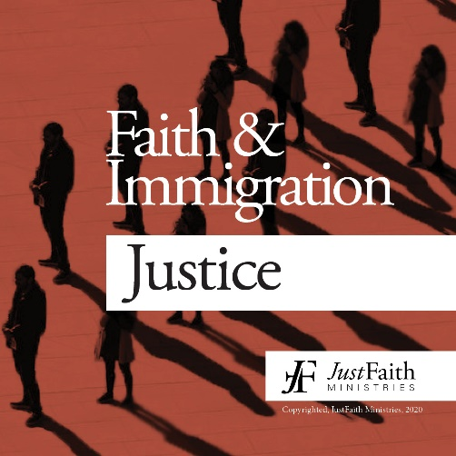

Faith & Immigration Justice
How do we have a healthy dialogue about immigration?
Faith and Immigration Justice is an eight-week program by JustFaith Ministries that facilitates holy and healthy dialogue around migration, a highly contentious topic that is nevertheless intricately linked with our Christian faith. By fostering active listening, dialogue, and prayer, this program forms a group that is rooted in trust and compassion. Through new learning from articles, videos, and books (Welcoming the Stranger by Jenny Hwang and Matthew Soerens and The Line Becomes a River by Francisco Cantú), it lends new insights to participants’ understanding of immigration policy and those affected by it. By encouraging new spiritual practices and informed action, it cultivates an expanding community of Christians who work for immigration justice in their respective contexts.

Available starting: ____________________
To learn more and register visit: https://justfaith.org/faith-and-immigration-justice/
Contact:

